**What Is The Most Effective Way To Destroy A Hard Drive?**

It is now a digital age and it is crucial that we protect our personal data, particularly those stored on hard drives on laptops and other computers. Not only will you put your confidential information at stake, but it also poses serious threats to the environment. Businesses that dispose of electronic waste in an unprofessional manner can be accused of damaging their reputation and could face lawsuits or heavy fines.

Many people believe that formatting a hard drive will protect their data. However, this is not true. Formatting hard drive data does not guarantee data destruction . It does not erase all data, but it makes some files invisible.

According to a recent research, despite prior owners' attempts to wipe the hard discs clean, 67 percent of hard drives acquired via Craigslist and eBay in 2015 still included shards of personal data from past owners. Company emails accounted for 9% of the identifiable data, while sensitive corporate data accounted for 11%.

In this article, I'll go over some of the facts surrounding hard drive destruction and explain why it's critical to seek the services of competent IT disposal professionals to do the operation.

**It's Not As Simple As You Think To Destroy A Hard Drive**

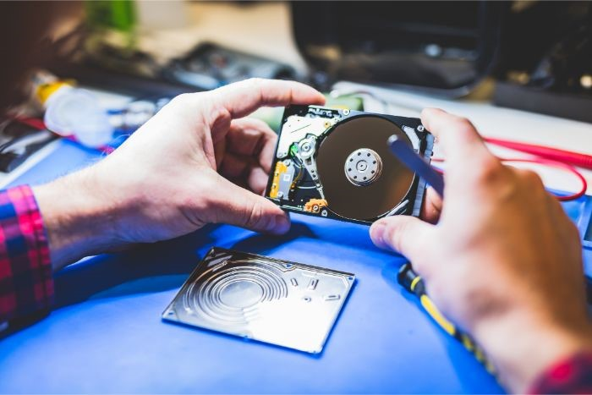

Most of you are now aware of the need of securely destroying hard drives before reselling or giving your laptops and PCs. You must now guarantee that all data on the hard disc is erased as completely as possible.

**Fact # 1 - A hard drive cannot be destroyed by water**

As hard discs are tightly sealed, dumping them in a bucket of water won't help you get rid of your personal information.

Water will, at some time, cause harm to your hard drive. In fact, submerging it in water for an extended period of time may cause it to cease working. It will not, however, assist you in removing the personal information included inside. Another reason this won't work is that hard drives are magnetically stored on the inside platters. As a result, the water is unlikely to have any effect on it.

**Fact # 2 - Degaussing Doesn’t Always Work**

Professionals degauss hard drives by passing them through a magnetic field, which reorganises the polarity of their particles, leaving the prior data unrecoverable. This strategy, however, will not work on SSDs since they do not store data magnetically.

Data is stored on these hard drives in the same manner as it is on a tablet or smartphone. Degaussing is an unsuccessful hard drive data destruction method for SSD devices since they use less power, are smaller, and are non-magnetic.

**Fact # 3 - Magnets Won’t Ruin Your Data**

This myth is most likely based on the fact that antiquated equipment like TVs and CRTs are magnetically vulnerable. Modern electronic equipment, such as hard drives, are impervious to magnets because they can withstand repeated magnetic field exposure.

They might be able to deactivate debit cards, but they're no match for practically deleting a hard drive. A prestigious publishing house previously experimented with putting hefty magnets on both sides of a working hard drive. They eventually discovered that the data on the drive had not been harmed.

**Fact # 4 - Formatting Your Hard Drive Will Not Erase Your Data**

The majority of us just wipe the data from our hard drives before discarding them. What we don't realise is that it puts our secrecy at danger.

An experiment on more than 200 hard discs was once undertaken by a group of MIT students. The previous owners had formatted more than half of the discs. Using forensic scraping software, the students were able to extract bank statements, medical records, and 5,000 credit card details from formatted hard discs.

**Fact # 5 - Software Programs Do Not Completely Remove Data From Hard Drives**

As most of you are aware, just deleting files from your hard drive will have no effect on the security of your data. It's the same as locking the front door of your house while leaving all of your possessions inside. They can still be stolen if a burglar enters through the rear door.

We are simply removing the formal access point to our personal data when we remove files from our PCs. Even the most advanced data erasure software can leave behind parts of your personal information that hackers can access and retrieve through other ways.

**Fact # 6 - Destroying a hard drive should be left to the professionals**

For easy and secure disposal of our hard discs, we need contact a genuine and recognised hard drive destruction service. This manner, you can rest certain that your gear and data are being handled correctly and in compliance with HMG guidelines.

For your personal piece of mind, reputable [data deletion providers](https://www.recyclepro.co.uk/) will also provide you with data destruction certifications.

You may entrust the security of your personal data to [Recycle Pro IT recycling](https://www.recyclepro.co.uk/). Not only will our licenced and skilled team assure the safe deletion of your data, but they will also prevent anyone from accessing it. If you want to learn more about our processes, you may contact us at any time.